S.1
History and Political Education
Paper 1
2024
July/August
2 ¼ hours

BSR JOINT ASSESSMENT
2024

UGANDA CERTIFICATE OF EDUCATION

HISTORY AND POLITICAL EDUCATION

PAPER 1 FOR S.1

2 HOURS 15 MINUTES

INSTRUCTIONS

- Attempt only two (2) scenarios

Turn over
Scenario 1:
One parent of a S.1 learner complained before the headteacher that although the government through National Curriculum Development Center (NCDC) reduced subjects done at O level, the subjects are still many on his small boy. The headteacher told him all the remaining subjects were left for a reason and that his boy was to benefit a lot. The parent rejected the headteacher’s argument and wondered how history political education will benefit his boy. The headteacher called you as one of the S.1 learners to help the parent understand why history and political education was left on the O level subject menu
Support material
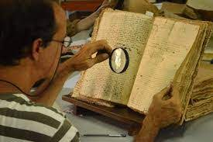
Territorio Sociales, 17th September 2019: Working as an historian
Task:
Write an essay of what you are going to tell the parent
Scenario 2:
During a history study tour in Kampala, a certain S.1 girl saw one of the guides that greatly resembled her father and brothers. The S.1 girl wondered how on earth a person can resemble another one that much. When she shared with her friends, they told her the guide must be her brother from another mother. The girl got confused the more. During holidays, she asked her father whether he had another son in Kampala, the father denied. The girl is not convinced and wants to find out on her own whether the guide is their brother but doesn’t know what to do. She asked you as her colleague to advise her on what to do to get facts
Task:
Write an essay advising her on what she can do
Scenario 3:
During a history research tour at Kasubi tombs, seminarians learned about Kintu. The tour guide narrated to them that he was the first human on earth. This shocked the students from the seminary, as they believed God created Adam as the first man. When they went back to the seminary, the teacher asked them to hand in their work they had written while on tour. They told him, they didn’t write anything because the tour guide deceived them. The teacher realised there was a problem with his students and hired you to come and help these students understand the tour guide well
Support material
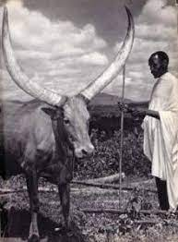
Uganda heritage tales and trails, March 2013: The story of Kintu and Nambi
Task
In a detailed essay, help the learners to understand the tour guide’s claim.
NB: For facilitations, call 0750025446/0784114269 (BAGUMA SSENTAMU RICHARD)

